**PROJECT REPORT**

**ON**

**Shop_Now.com an E-Commerce Website**

Submitted By

## **Sunit Kumar Pattnaik - 160301120132**

**Under the supervision of Asst. Prof Mr. Rakesh Kumar Ray**

**Department of Computer Science & Engineering**

**In partial fulfilment for the award of the degree of**

**Bachelor of Technology**

**In**

**Computer Science & Engineering**

**Centurion University of Technology & Management**

**Jatni Campus, Pin Code: 752050, Bhubaneswar Odisha**

**March 2019**

**CERTIFICATE**

This is to be certified that the project entitled “Shop_Now.com” has been submitted for the Bachelor of Technology in Computer Science Engineering of School of Engineering & Technology, CUTM, Jatni during the academic year 2018-2019 is a persuasive piece of project work carried out by “**Sujit Kumar Nayak, Sunit Kumar Pattnaik, Sambit Kumar Baral, Santanu Kumar Sahoo, Rahul Dhal**” towards the partial fulfillment for award of the degree (B.Tech.) under the guidance of “Mr Rakesh Kumar Ray” and no part thereof has been submitted by them for any degree to the best of my knowledge.

Signature of HoD/Dean Signature of Project Guide

**Dr. Prasanta Mohanty Asst. Prof. Mr. Rakesh Kumar Ray**

Signature of Coordinator

**Mr. Rakesh Kumar Ray**

**Asst. Director Project**

Page | **2**

**DECLARATION**

We, hereby declare that the work presented in this dissertation entitled **“Shop_Now.com”** has done by us, and this dissertation embodies our own work under the guidance of **“Mr. Rakesh Kumar Ray”** of **“Major Programming Project”** subject of Computer Science and Engineering at **“Centurion Institute of Technology”**.

Place: (Mr. Rakesh Kumar Ray)

Date:

## 

## **SUNIT KUMAR PATTNAIK (160301120132)**

Page | **3**

**ACKNOWLEGEMENT**

We take this occasion to thank God, almighty for blessing us with his grace and taking our endeavor to a successful culmination. We extend our sincere and heartfelt thanks to our esteemed guide, Mr. Rakesh Kumar Ray for providing us with the right guidance and advice at the crucial junctures and for showing us the right way. We extend our sincere thanks to our respected head of the division Mr. P K Mohanty, for allowing us to use the facilities available. We would like to thank the other faculty members also, at this occasion.

Last but not the least, we would like to thank friends for the support and encouragement they have given us during the course of our work.

## **SUNIT KUMAR PATTNAIK (160301120132)**

Page | **4**

**EVALUATION SHEET**

1. Title of the Project: Shop_Now.com
2. Year of submission:2019
3. Name of the degree: B. tech
4. Date of Examination / Viva:
5. Student Name with Reg No.:

Sunit Kumar Pattnaik – 160301120132

Name of the Guide:

1. Result:

Signature of HoD/Dean Signature of Project Guide

**Dr. Prasanta Mohanty Asst. Prof. Mr. Rakesh Kumar Ray**

Signature of Coordinator

**Mr. Rakesh Kumar Ray**

**Asst. Director Project**

Page | **5**

**ABSTRACT**

The Shopping cart is mainly useful for who haven’t time to go to shopping, those are just entered into this website and bought whatever they want. Even it is night or morning they entered into this site, and chosen different items like fruits, books, toys etc. ‘Customer is our god’ mainly this website is based on this formula. After chosen items he bought into Pay pal process like VISA or MASTER credit cards or any Debit cards are accepted in this website. Customer is happily shopping at his rest place.

Once customer entered with his own username and password, at that time automatically one shopping cart will be created, once user select an item it will add to cart. In case user thinks the selected item is not useful for me, then deleted that item from shopping cart.

Customer selected some items, but in his credit or debit cart haven’t that much balance, then he was logout from the website, the selected items are stored at cart with specific users with his allotted carts, after some days he bought those items then automatically deleted from the cart.

Page| **6**

INDEX

|  |  |  |
| --- | --- | --- |
| **SI NO** | **CONTENTS** | **PAGE NO** |
| **1** | **INTRODUCTION** | **8** |
| **2** | **LITERATURE REVIEW** | **9** |
| **3** | **SYSTEM ANALYSIS** | **10** |
|  | **2.1 SYSTEM SPECIFICATION** |  |
|  | **2.3FEASIBILITY STUDY** |  |
| **4** | **DESIGN APPROACH** | **11-27** |
|  | **4.1 INTRODUCTION TO DESIGN** |  |
|  | **4.2 UML DIAGRAMS** |  |
|  | **4.3 DATA FLOW DIAGRAMS** |  |
|  | **4.4 E R DIAGRAMS** |  |
| **5** | **PROJECT MODULES** | **28** |
| **6** | **CONCEPTS AND TECHNIQUES** | **29-35** |
| **7** | **IMPLEMENTATIONS** | **36** |
| **8** | **SOFTWARE METHODOLOGY** | **37-38** |
| **9** | **TESTING** | **39-41** |
| **10** | **OUTPUT SNAPSHOTS** | **42-49** |
| **11** | **CONCLUSION** | **50** |
| **12** | **FUTURE ENHANCEMENTS** | **51** |
| **13** | **BIBLIOGRAPHY** | **52** |

**Page | 7**

1. **INTRODUCTION**

**OBJECTIVE:**

The Shopping cart is mainly useful for who haven’t time to go to shopping, those are just entered into this website and bought whatever they want. Even it is night or morning they entered into this site, and chosen different items like fruits, books, toys etc. ‘Customer is our god’ mainly this website is based on this formula. After chosen items he bought into Pay pal process like VISA or MASTER credit cards or any Debit cards are accepted in this website. Customer is happily shopping at his rest place.

**PROJECT OVERVIEW:**

Once customer entered with his own username and password, at that time automatically one shopping cart will be created, once user select an item it will add to cart. In case user thinks the selected item is not useful for me, then deleted that item from shopping cart.

Customer selected some items, but in his credit or debit cart haven’t that much balance, then he was logout from the website, the selected items are stored at cart with specific users with his allotted carts, after some days he bought those items then automatically deleted from the cart.

**Page | 8**

## **ANALYSIS**

**SYSTEM ANALYSIS**:

1. Existing System

Existing system is a manual one in which users are maintaining books to store the information like product details, purchases, sales details and accounts for every month. It is very difficult to maintain historical data.

**DISADVANTAGES:**

The following are the disadvantages of the existing system

* It is difficult to maintain important information in books.
* More manual hours need to generate required reports.
* It is tedious to manage historical data which needs much space to keep all the previous years’ ledgers, books etc.
* Daily sales and purchases details must be entered into books are very difficult to maintain.

**3. Objective of the System**

The objective of the Shopping Cart is to provide better information for the users of this system for better results for their maintenance in the product details that is sales, purchases and stock.

Page | **9**

**2.1 System Specifications**

**Hardware Requirements:-**

* Dual Core (Processor).
* 256 MB Ram
* 512 KB Cache Memory
* Hard disk 10 GB
* Microsoft Compatible 101 or more Key Board

**Software Requirements: -**

Technology Implemented: Apache Server

Language Used : PHP 5.62 (Developed in Core PHP)

Database : MySQL

User Interface Design : HTML, AJAX, JQUERY, JAVASCRIPT

Editor : Sublime Text

Web Browser : Mozilla, Google Chrome

Software :WAMP Server

Page | **10**

**4.1 DESIGN**

**INTRODUCTION**

Design is the first step in the development phase for any techniques and principles for the purpose of defining a device, a process or system in sufficient detail to permit its physical realization.

Once the software requirements have been analyzed and specified the software design involves three technical activities - design, coding, implementation and testing that are required to build and verify the software.

The design activities are of main importance in this phase, because in this activity, decisions ultimately affecting the success of the software implementation and its ease of maintenance are made. These decisions have the final bearing upon reliability and maintainability of the system. Design is the only way to accurately translate the customer’s requirements into finished software or a system.

Design is the place where quality is fostered in development. Software design is a process through which requirements are translated into a representation of software. Software design is conducted in two steps. Preliminary design is concerned with the transformation of requirements into data.

Page | **11**

**4.2 UML DIAGRAMS**

Actor: A coherent set of roles that users of use cases play when interacting with the use `cases.

Use case: A description of sequence of actions, including variants, that a system performs that yields an observable result of value of an actor.

UML stands for Unified Modeling Language. UML is a language for specifying, visualizing and documenting the system. This is the step while developing any product after analysis. The goal from this is to produce a model of the entities involved in the project which later need to be built. The representation of the entities that are to be used in the product being developed need to be designed.

Page | **12**

There are various kinds of methods in software design:

They are as follows:

* Use case Diagram
* Sequence Diagram
* Collaboration Diagram
* Activity Diagram
* State chat Diagram

**USECASE DIAGRAMS:**

A Use case is a description of set of sequence of actions. Graphically it is rendered as an ellipse with solid line including only its name. Use case diagram is a behavioral diagram that shows a set of use cases and actors and their relationship. It is an association between the use cases and actors. An actor represents a real-world object. Primary Actor – Sender, Secondary Actor Receiver.

Use case diagrams model behavior within a system and helps the developers understand of what the user require. The stick man represents what’s called an actor.

Use case diagram can be useful for getting an overall view of the system and clarifying who can do and more importantly what they can’t do.

Use case diagram consists of use cases and actors and shows the interaction between the use case and actors.

* The purpose is to show the interactions between the use case and actor.
* To represent the system requirements from user’s perspective.
* An actor could be the end-user of the system or an external system.

Page | **13**



**Page | 14**

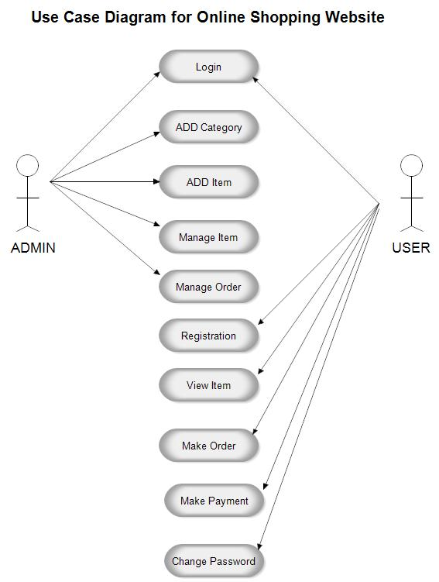

Page | **15**

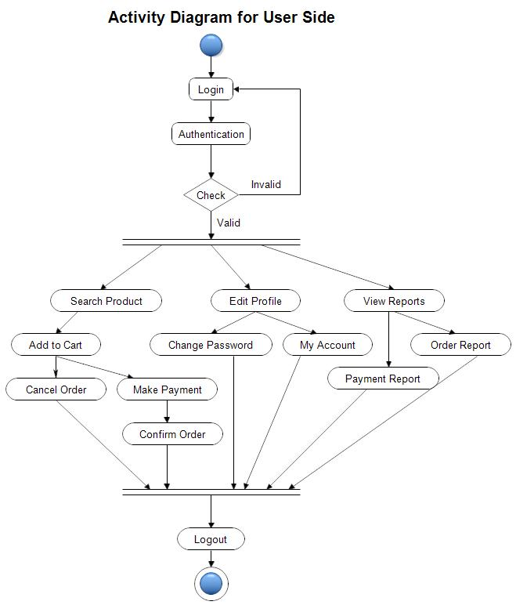

Page | **16**

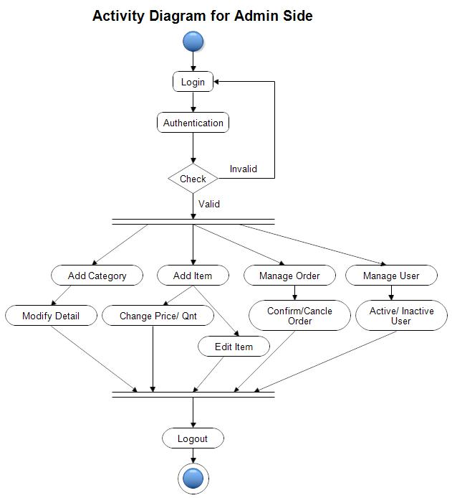

Page | **17**

**SEQUENCE DIAGRAM**

Sequence diagram and collaboration diagram are called INTERACTION DIAGRAMS. An interaction diagram shows an interaction, consisting of set of objects and their relationship including the messages that may be dispatched among them.

A sequence diagram is an introduction that empathizes the time ordering of messages. Graphically a sequence diagram is a table that shows objects arranged along the X-axis and messages ordered in increasing time along the Y-axis.

Page | **18**



**COLLABORATION DIAGRAM:**

A collaboration diagram is an introduction diagram that emphasizes the structural organization of the objects that send and receive messages. Graphically a collaboration diagram is a collection of vertices and arcs.

Page | **19**



**CLASS DIAGRAM:**

Class is nothing but a structure that contains both variables and methods. The Class Diagram shows a set of classes, interfaces, and collaborations and their relating ships. There is most common diagram in modeling the object oriented systems and are used to give the static view of a system. It shows the dependency between the classes that can be used in our system.

Page | **20**

The interactions between the modules or classes of our projects are shown below. Each block contains Class Name, Variables and Methods.

**CLASS:**

A description of set of objects that share the same attributes, operations, relationships, and semantics.

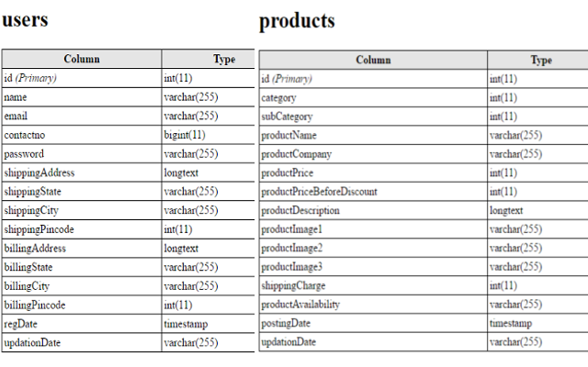

Page | **21**



Page | **22**

**DATA FLOW DIAGRAMS**

The DFD takes an input-process-output view of a system i.e. data objects flow into the software, are transformed by processing elements, and resultant data objects flow out of the software.

Data objects represented by labeled arrows and transformation are represented by circles also called as bubbles. DFD is presented in a hierarchical fashion i.e. the first data flow model represents the system as a whole. Subsequent DFD refine the context diagram (level 0 DFD), providing increasing details with each subsequent level.

The DFD enables the software engineer to develop models of the information domain & functional domain at the same time. As the DFD is refined into greater levels of details, the analyst perform an implicit functional decomposition of the system. At the same time, the DFD refinement results in a corresponding refinement of the data as it moves through the process that embody the applications.

A context-level DFD for the system the primary external entities produce information for use by the system and consume information generated by the system. The labeled arrow represents data objects or object hierarchy.

**RULES FOR DFD:**

* Fix the scope of the system by means of context diagrams.
* Organize the DFD so that the main sequence of the actions
* Reads left to right and top to bottom.
* Identify all inputs and outputs.
* Identify and label each process internal to the system with Rounded circles.
* A process is required for all the data transformation and Transfers. Therefore, never connect a data store to a data Source or the destinations or another data store with just a Data flow arrow.
* Do not indicate hardware and ignore control information.
* Make sure the names of the processes accurately convey everything the process is done.
* There must not be unnamed process.
* Indicate external sources and destinations of the data, with Squares.
* Number each occurrence of repeated external entities.
* Identify all data flows for each process step, except simple Record retrievals.
* Label data flow on each arrow.
* Use details flow on each arrow.
* Use the details flow arrow to indicate data movements.

Page | **23**

Database:

**User Registration**

**Buying Product**

DATABASE

**Page | 24**

**USER REGISTRATION**

View user details

Order History

Search for user details

Update user details

Register user

**BUYING PRODUCT**

View products

Delete Cart

Make Payment

Add to Cart

Buy product

**Page | 25**

**DFD FULL**

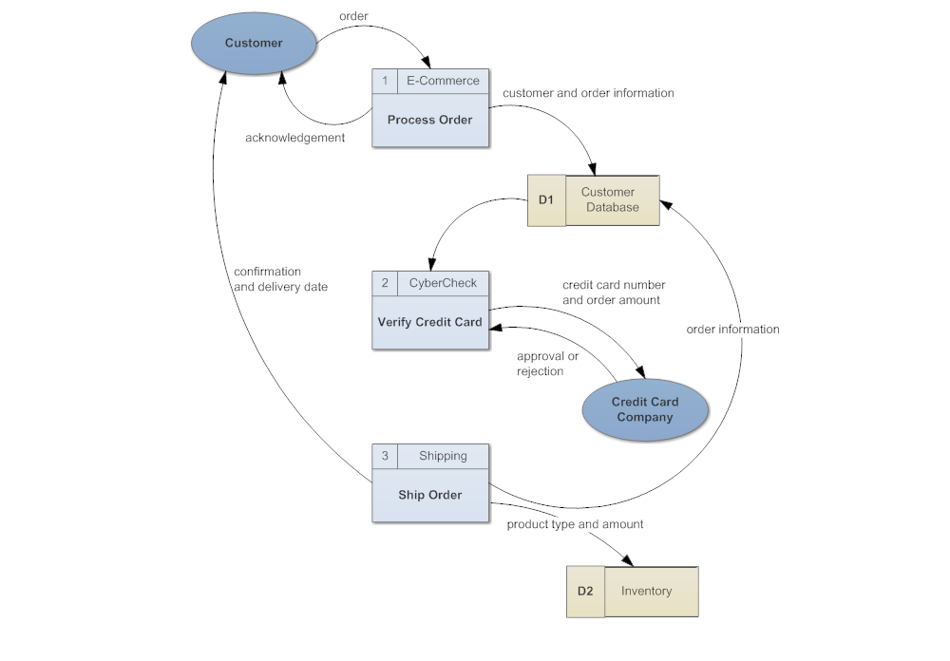

**Page | 26**

**Diagrams:**

Simply stated the ER model is a conceptual data model that views the real world as entities and relationships. A basic component of the model is the Entity-Relationship diagram which is used to visually represent data objects. Since Chen wrote his paper the model has been extended and today it is commonly used for database design for the database designer.

**4.4 ER DIAGRAM**

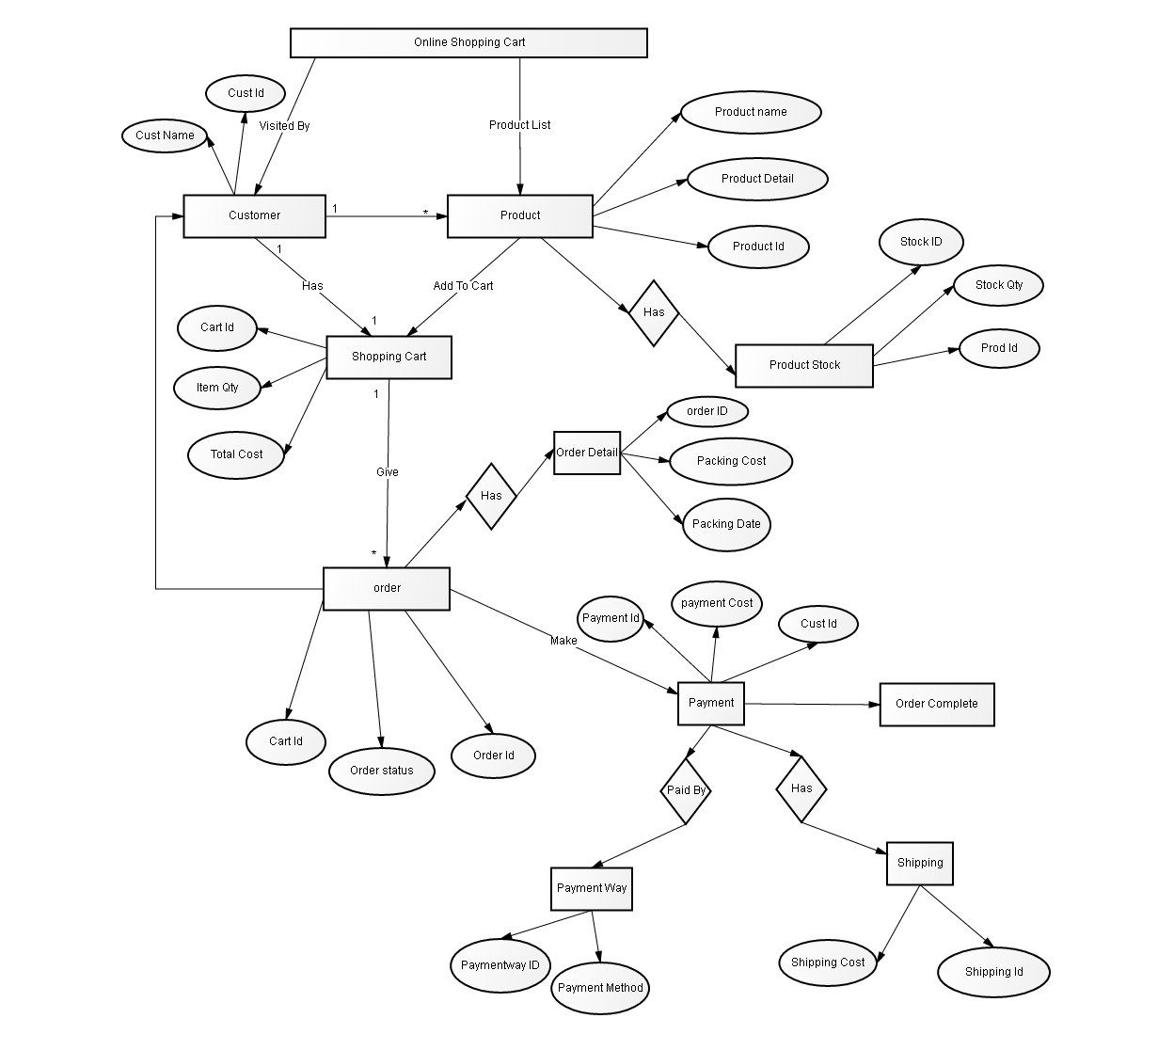

Page | **27**

**5.MODULES**

**PROJECT MODULES**

This project contains 3 modules, those are

* **Admin (Single Admin)**
* **Products**
* **User**

**MODULES DESCRIPTION**

**Admin:**

When admin login, he saw the customer’s database, means how many users are authenticated to this website and how many users are transact every day, and newly items are inserting into products.

**Products:**

This module contains product name, and related image, and cost of its. Like toys, books, furniture, gold items, etc. Whatever customer wants from the shopping cart.

**User:**

User entered into with his username and password, when he entered into this, he saw what items are available today, and this facility is available for this site. Chosen different items from website get those through door delivery.

Page | **28**

# **6. OVERVIEW OF TECHNOLOGIES USED**

# **3.1 Front End Technology**

# **PHP**

## PHP is a server-side scripting language designed specifically for the web. Within an HTML page, you can embed PHP code that will be executed each time the page is visited. Your PHP code is interpreted at the web server and generates HTML or other output that the visitor will see. PHP was introduced in 1994. As of November 2007, it was installed on more than 21 million domains worldwide, and this number is growing rapidly. You can see the current number at <http://www.php.net/usage.php> PHP is an Open Source project. PHP originally stood for Personal Home Page and now stands for PHP Hypertext Preprocessor.

## **Unique Features**

If you are familiar with other server side language like ASP.NET or JSP you might be wondering what makes PHP so special, or so different from these competing alternatives well, here are some reasons:

1. Performance
2. Portability(Platform Independent)
3. Ease Of Use
4. Open Source
5. Third-Party Application Support
6. Community Support

**Page | 29**

**PERFORMANCE**

Scripts written in PHP executives faster than those written in other scripting language, with numerous independent benchmarks, putting the language ahead of competing alternatives like JSP, ASP.NET and PERL. The PHP 5.0 engine was completely redesigned with an optimized memory manager to improve performance, and is noticeable faster than previous versions. In addition, third party accelerators are available to further improve performance and response time.

### **Portability**

PHP is available for UNIX, MICROSOFT WINDOWS, MAC OS, and OS/2.PHP Programs are portable between platforms. As a result, a PHP application developed on, say, Windows will typically run on UNIX without any significant issues. This ability to easily undertake cross-platform development is a valuable one, especially when operating in a multi-platform corporate environment or when trying to address multiple market segments.

### **Ease of Use**

“Simplicity is the ultimate sophistication”, Said Leonardo da Vinci, and by that measure, PHP is an extremely sophisticated programming language. Its syntax is clear and consistent, and it comes with exhaustive documentation for the 5000+ functions included with the core distributions. This significantly reduces the learning curve for both novice and experienced programmers, and it’s one of the reasons that PHP is favored as a rapid prototyping tool for Web-based applications.

### **Open Source**

PHP is an open source project – the language is developed by a worldwide team of volunteers who make its source code freely available on the Web, and it may be used without payment of licensing fees or investments in expensive hardware or software .This reduces software development costs without affecting either flexibility or reliability The open-source nature of the code further means that any developer, anywhere , can inspect the code tree, spit errors, and suggest possible fixes, this produces a stable, robust product wherein bugs, once discovered, are rapidly resolved – sometimes within a few hours of discovery !.

Page | **30**

**Third-Party Application Support**

One of PHP’s Strengths has historically been its support for a wide range of different databases, including MySQL, PostgreSQL, Oracle, and Microsoft SQL Server. PHP 5.3 Supports more than fifteen different database engines, and it includes a common API for database access. XML support makes it easy to read and write XML documents though they were native PHP data structures, access XML node collections using Xpath, and transform XML into other formats with XSLT style sheets.

### **Community Support**

One of the nice things about a community-supported language like PHP is the access it offers to the creativity and imagination of hundreds of developers across the world. Within the PHP community, the fruits of this creativity may be found in PEAR, the PHP Extension and Application Repository and PECL, the PHP Extension Community Library, which contains hundreds of ready-made widgets and extensions that developers can use to painlessly and new functionality to PHP. Using these widgets is often a more time-and cost-efficient alternative to rolling your own code.

## **PHP Server**

The PHP Community Provides Some types of Software Server solution under The GNU (General Public License).

### These are the following:

WAMP Server

LAMP Server

MAMP Server

XAMPP Server

All these types of software automatic configure inside operating system after installation it having PHP, MySQL, Apache and operating system base configuration file, it doesn’t need to configure manually.

WAMP- Microsoft window o/s,Apache MySQL PHP

LAMP - Linux Operating System Apache MySQL PHP

MAMP - Mac osApache MySQL PHP

XAMPP -x-OS (cross operating system) Apache MySQL PHP Perl

**Page | 31**

**Introduction to HTML**

The hypertext markup language (HTML) is a simple markup language. Used to create a hypertext documents that are portable from one platform to another HTML documents are SGML (Standard generalized markup language) documents with generic semantics that are appropriate for representing information from a wide range of applications.

WHY TO USE HTML?

Website is a collection of pages, publications, and documents that reside on web server. While these pages publications and a document as a formatted in a single format, you should use HTML for home page and all primary pages in the site. This will enable the millions of web users can easily access and to take advantage of your website.

**BACK END TECHNOLOGY:**

**MYSQL: Introduction**

There are a large number of database management systems currently available, some commercial and some free.

Some of them: **Oracle, Microsoft Access, MySQL and PostgreSQL**.

These database systems are powerful, feature-rich software, capable of organizing and searching millions of records at very high speeds.

### Understanding Databases, Records, and Primary Keys

Every Database is composed of one or more tables.

These Tables, which structure data into rows and columns, impose organization on the data.

The records in a table (below) are not arranged in any particular order.

## **PHP MySQL connectivity**

Use the **mysql_connect( )** function to established connection to the MySQL server.

To access the database functionality we have to make a connection to database using PHP.

Page | **32**

mysql_connect() function is used to establish the connection to MySQL server.  
Four arguments need to be passed to mysql_connect () function.

**hostname:** if you are working on local system, you can use localhost or you can also provide ip address or server name.

**username:** if there is an existing user, you can provide username.

Default username is ‘root’.

**password:** by default password is blank or null.

**dbname:** it is aN optional field . it is basically a name of the database that need to be connected.

NOTE: In our project dbname is “shopping”

mysql_connect(host,username,password,dbname);

**host(Server name)----** Either a host name(server name) or an IP address

**Username----** the MySQL user name

**Password----** The password to log in with

**dbname----** Optional. The database to be used when performing queries

Note : There are more available parameters, but the ones listed above are the most important.

In the following example we store the connection in a variable ($con) for later use in the script.

<?php

define('DB_SERVER','localhost');

define('DB_USER','root');

define('DB_PASS' ,'');

define('DB_NAME', 'shopping');

$con = mysqli_connect(DB_SERVER,DB_USER,DB_PASS,DB_NAME);

// Check connection

if (mysqli_connect_errno())

{ Page | **33**

echo "Failed to connect to MySQL: " .mysqli_connect_error();

}

?>

Here localhost is server name. root is MySQL default user name. default password is blank and database name is “shopping” my_db. **mysql_error( )** function provides mysql connectivity error message.

### **MySQL Close Connection**

<?php

// Create connection

$con=mysql_connect("localhost","root","","my_db") or die(mysql_error());

//code to be executed.

// Close connection

mysql_close($con);

?>

After work with the database is done we have to close the connection using mysql_close()functionin which the connection to the database is passed.

**Page | 34**

**FEASIBILITY STUDY**

Feasibility study is conducted once the problem is clearly understood. Feasibility study is a high level capsule version of the entire system analysis and design process. The objective is to determine quickly at a minimum expense how to solve a problem. The purpose of feasibility is not to solve the problem but to determine if the problem is worth solving.

The system has been tested for feasibility in the following points.

**1. Technical Feasibility**

The project entitles "SHOPPING KARO.com” is technically feasibility because of the below mentioned feature. The project was developed in PHP.

It provides the high level of reliability, availability and compatibility. All these make PHP an appropriate language for this project. Thus the existing PHP is a suitable language.

**2. Economic Feasibility**

The computerized system will help in automate the selection leading the profits and details of the organization. With this software, the machine and manpower utilization are expected to go up by 80-90% approximately. The costs incurred of not creating the system are set to be great, because precious time can be wanted by manually.

**3. Operational Feasibility**

In this project, the management will know the details of each project where he may be presented and the data will be maintained as decentralized and if any inquires for that particular contract can be known as per their requirements and necessaries.

**Page | 35**

1. **IMPLEMENTATION**

Implementation is the stage where the theoretical design is turned into a working system. The most crucial stage in achieving a new successful system and in giving confidence on the new system for the users that it will work efficiently and effectively.

The system can be implemented only after thorough testing is done and if it is found to work according to the specification.

It involves careful planning, investigation of the current system and its constraints on implementation, design of methods to achieve the change over and an evaluation of change over methods a part from planning. Two major tasks of preparing the implementation are education and training of the users and testing of the system.

The more complex the system being implemented, the more involved will be the systems analysis and design effort required just for implementation.

The implementation phase comprises of several activities. The required hardware and software acquisition is carried out. The system may require some software to be developed. For this, programs are written and tested. The user then changes over to his new fully tested system and the old system is discontinued.

Page | **36**

# **SOFTWARE METHODOLOGY**

The software methodology followed in this project includes the object-oriented methodology and the application system development methodologies. The description of these methodologies is given below.

Application System Development – A Life cycle Approach

Although there are a growing number of applications (such as decision support systems) that should be developed using an experimental process strategy such as prototyping, a significant amount of new development work continue to involve major operational applications of broad scope. The application systems are large highly structured. User task comprehension and developer task proficiency is usually high. These factors suggest a linear or iterative assurance strategy. The most common method for this stage class of problems is a system development life cycle modal in which each stage of development is well defined and has straightforward requirements for deliverables, feedback and sign off.

The basic idea of the system development life cycle is that there is a well-defined process by which an application is conceived and developed and implemented. The life cycle gives structure to a creative process. In order to manage and control the development effort, it is necessary to know what should have been done, what has been done, and what has yet to be accomplished. The phrases in the system development life cycle provide a basis for management and control because they define segments of the flow of work, which can be identified for managerial purposes and specifies the documents or other deliverables to be produced in each phase.

The phases in the life cycle for information system development are described differently by different writers, but the differences are primarily in the amount of necessity and manner of categorization. There is a general agreement on the flow of development steps and the necessity for control procedures at each stage.

The information system development cycle for an application consists of three major stages.

Definition.

Development.

Installation and operation.

The first stage of the process, which defines the information requirements for a feasible cost effective system. The requirements are then translated into a physical system of forms, procedures, programs etc., by the system design, computer programming and procedure development. The resulting system is test and put into operation. No system is perfect so there is always a need for maintenance changes. To complete the cycle, there should be a post audit of the system to evaluate how well it performs and how well it meets the cost and performance specifications. The stages of definition, development and installation and operation can therefore be divided into smaller steps or phrases as follows.

**Definition**

**Proposed definition :** preparation of request for proposed applications.

**Feasibility assessment:** evaluation of feasibility and cost benefit of proposed system.

**Information requirement analysis:** determination of information needed.

**Design**

**Conceptual design :** User-oriented design of application development.

**Physical system design:** Detailed design of flows and processes in applications processing system and preparation of program specification.

Development

**Program development :** coding and testing of computer programs.

**Procedure development :** design of procedures and preparation of user instructions.

**Installation and operation**

**Conversion :** final system test and conversion.

**Operation and maintenance:** Month to month operation and maintenance

**Post audit :** Evaluation of development process, application system and results of use at the completion of the each phase, formal approval sign-off is required from the users as well as from the manager of the project development.

Page | **38**

1. **TESTING**

Testing is a process of executing a program with the intent of finding an error. Testing is a crucial element of software quality assurance and presents ultimate review of specification, design and coding.

System Testing is an important phase. Testing represents an interesting anomaly for the software. Thus a series of testing are performed for the proposed system before the system is ready for user acceptance testing.

A good test case is one that has a high probability of finding an as undiscovered error. A successful test is one that uncovers an as undiscovered error.

**Testing Objectives:**

Testing is a process of executing a program with the intent of finding an error.

A good test case is one that has a probability of finding an as yet undiscovered error.

A successful test is one that uncovers an undiscovered error.

**Testing Principles:**

All tests should be traceable to end user requirements

Tests should be planned long before testing begins

Testing should begin on a small scale and progress towards testing in large

Exhaustive testing is not possible

To be most effective testing should be conducted by an independent third party

The primary objective for test case design is to derive a set of tests that has the highest livelihood for uncovering defects in software. To accomplish this objective two different categories of test case design techniques are used. They are

White box testing.

Black box testing.

# **White-box testing:**

White box testing focus on the program control structure. Test cases are derived to ensure that all statements in the program have been executed at least once during testing and that all logical conditions have been executed.

Page | **39**

# **Block-box testing:**

Black box testing is designed to validate functional requirements without regard to the internal workings of a program. Black box testing mainly focuses on the information domain of the software, deriving test cases by partitioning input and output in a manner that provides through test coverage. Incorrect and missing functions, interface errors, errors in data structures, error in functional logic are the errors falling in this category.

**Testing strategies:**

A strategy for software testing must accommodate low-level tests that are necessary to verify that all small source code segment has been correctly implemented as well as high-level tests that validate major system functions against customer requirements.

**Testing fundamentals:**

Testing is a process of executing program with the intent of finding error. A good test case is one that has high probability of finding an undiscovered error. If testing is conducted successfully it uncovers the errors in the software. Testing cannot show the absence of defects, it can only show that software defects present.

**Testing Information flow**:

Information flow for testing flows the pattern. Two class of input provided to test the process. The software configuration includes a software requirements specification, a design specification and source code.

Test configuration includes test plan and test cases and test tools. Tests are conducted and all the results are evaluated. That is test results are compared with expected results. When erroneous data are uncovered, an error is implied and debugging commences.

**Unit Testing:**

Unit testing is essential for the verification of the code produced during the coding phase and hence the goal is to test the internal logic of the modules. Using the detailed design description as a guide, important paths are tested to uncover errors with in the boundary of the modules. These tests were carried out during the programming stage itself. All units of ViennaSQLwere successfully tested.

**Page | 40**

**Integration testing:**

Integration testing focuses on unit tested modules and build the program structure that is dictated by the design phase.

**System testing:**

System testing tests the integration of each module in the system. It also tests to find discrepancies between the system and its original objective, current specification and system

documentation. The primary concern is the compatibility of individual modules. Entire system is working properly or not will be tested here, and specified path ODBC connection will correct or not, and giving output or not are tested here these verifications and validations are done by giving input values to the system and by comparing with expected output. Top-down testing implementing here.

## **Acceptance Testing:**

This testing is done to verify the readiness of the system for the implementation. Acceptance testing begins when the system is complete. Its purpose is to provide the end user with the confidence that the system is ready for use. It involves planning and execution of functional tests, performance tests and stress tests in order to demonstrate that the implemented system satisfies its requirements.

Tools to special importance during acceptance testing include:

Test coverage Analyzer – records the control paths followed for each test case.

Timing Analyzer – also called a profiler, reports the time spent in various regions of the code are areas to concentrate on to improve system performance.

Coding standards – static analyzers and standard checkers are used to inspect code for deviations from standards and guidelines.

**Test Cases:**

Test cases are derived to ensure that all statements in the program have been executed at least once during testing and that all logical conditions have been executed.

Using White-Box testing methods, the software engineer can drive test cases that

1. Guarantee that logical decisions on their true and false sides.
2. Exercise all logical decisions on their true and false sides.
3. Execute all loops at their boundaries and within their operational bounds.
4. Exercise internal data structure to assure their validity.

The test case specification for system testing has to be submitted for review before system testing commences.

1. OUTPUT SNAPSHOTS

**Page | 42**

**INDEX / HOMEPAGE**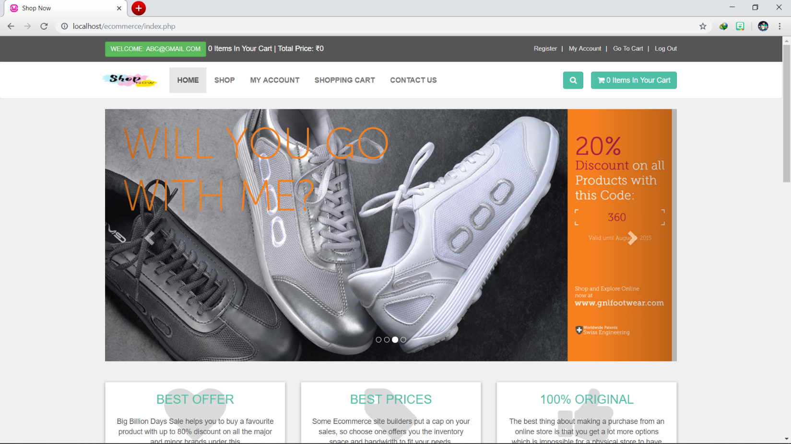

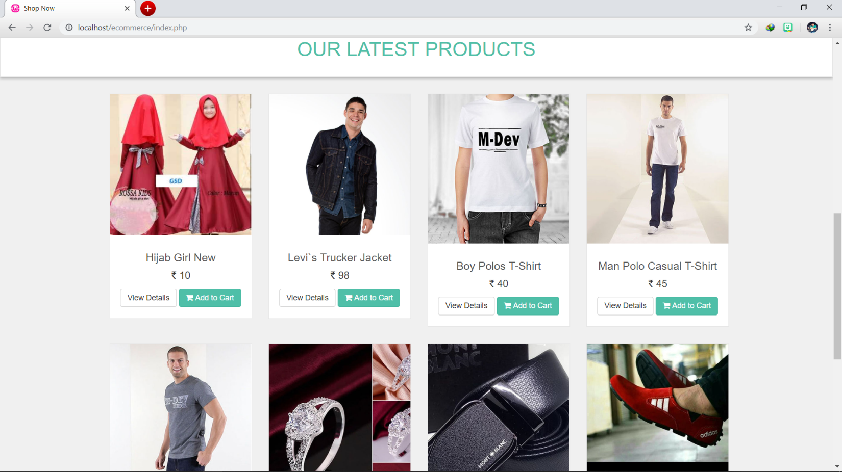

**Page | 43**

**User Login & Registration**

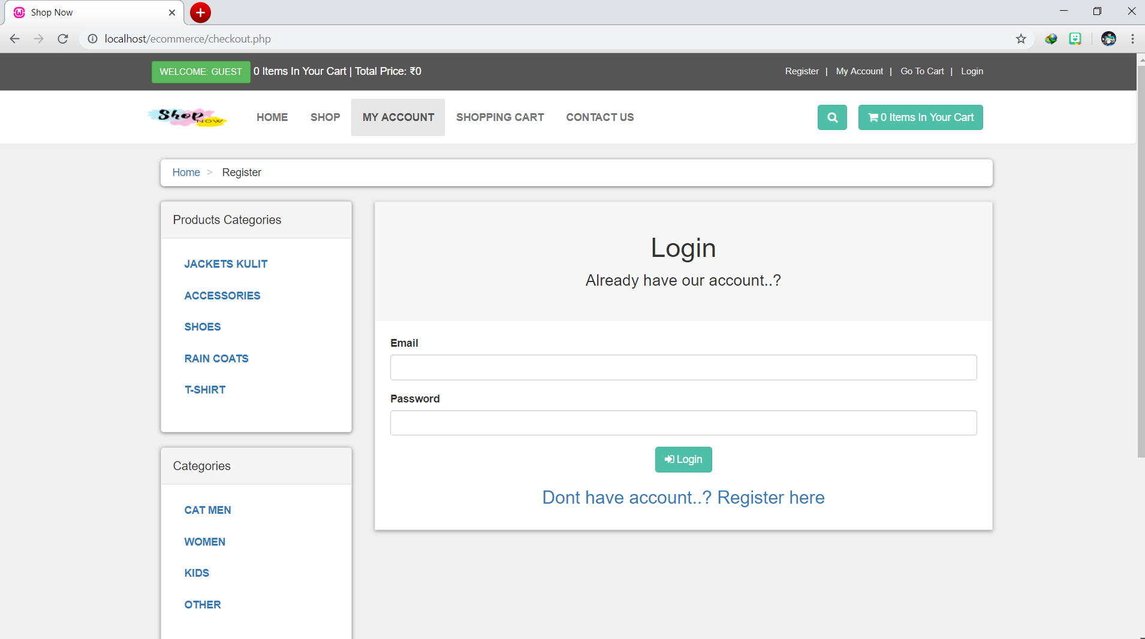

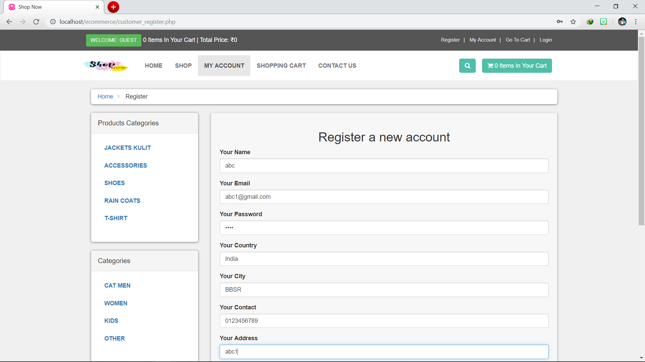

**Page | 44**

**PRODUCT DETAILS**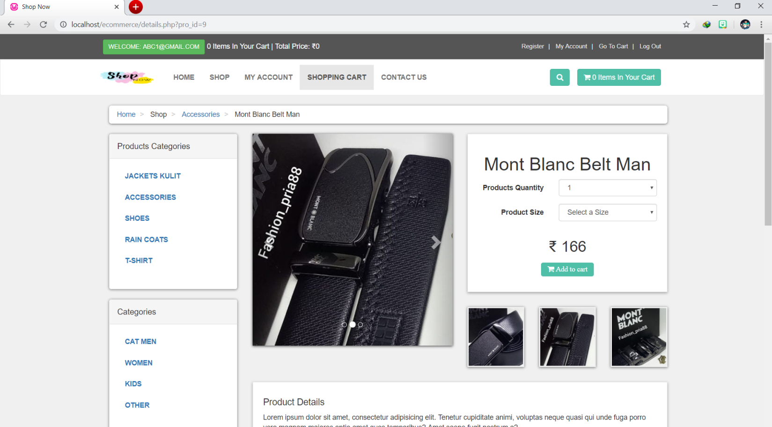

**CHANGE PASSWORD**

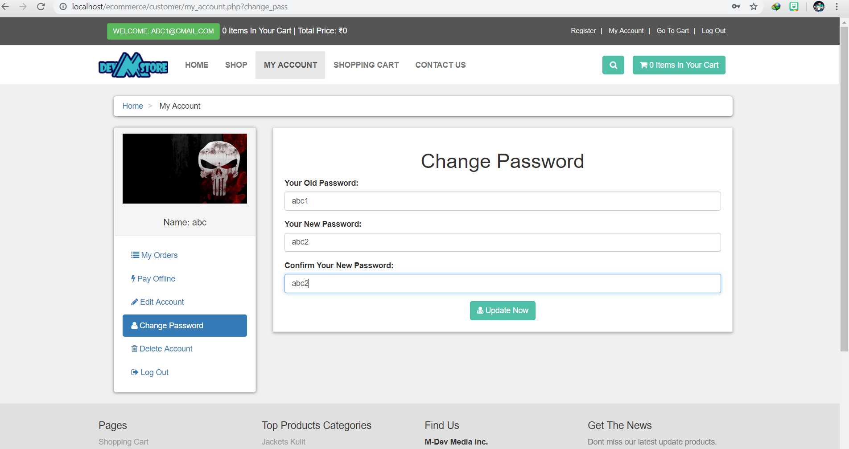

**Page | 45**

**SHOPPING CART** 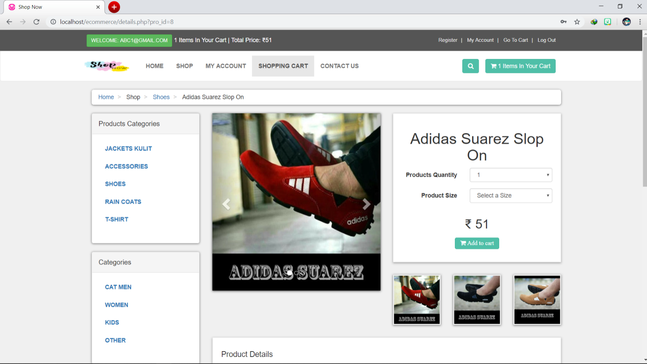

**CHECKOUT**

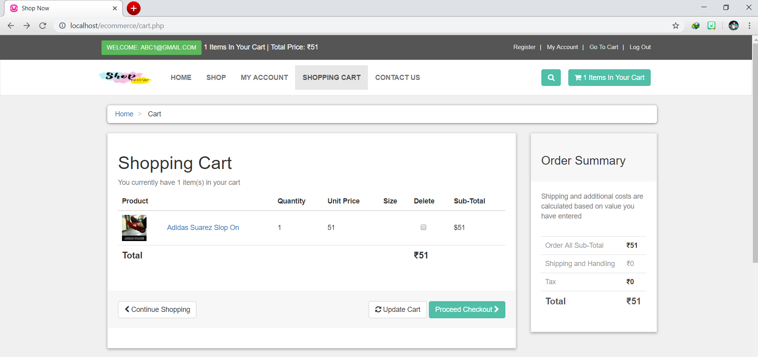

**Page | 46**

**PAYMENT**

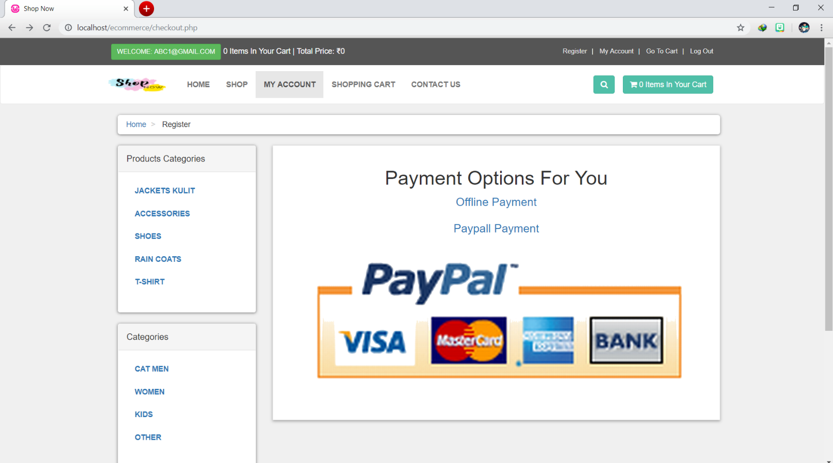

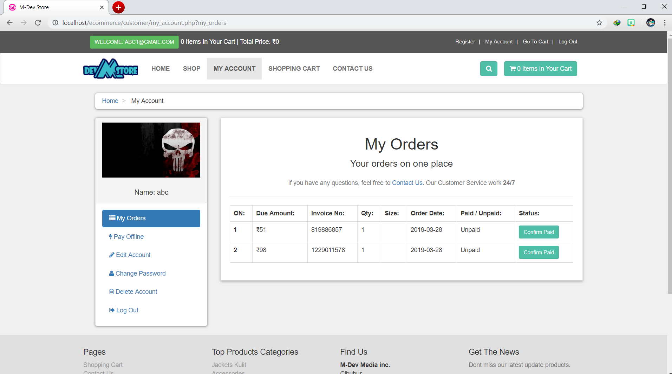

**Page | 47**

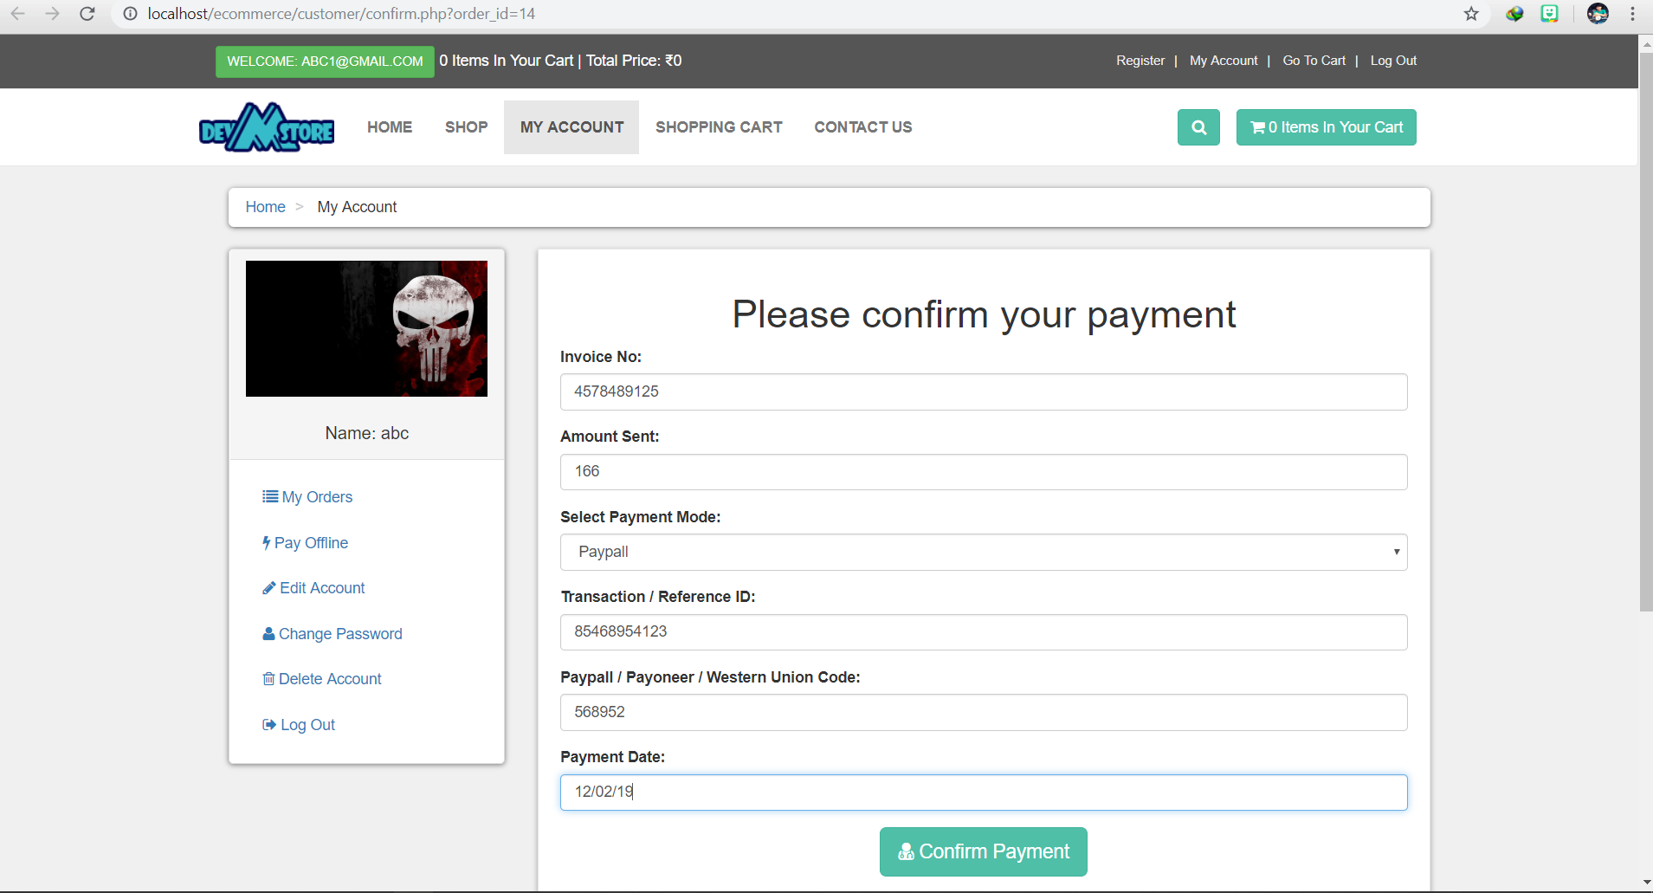

**PAY OFFLINE**

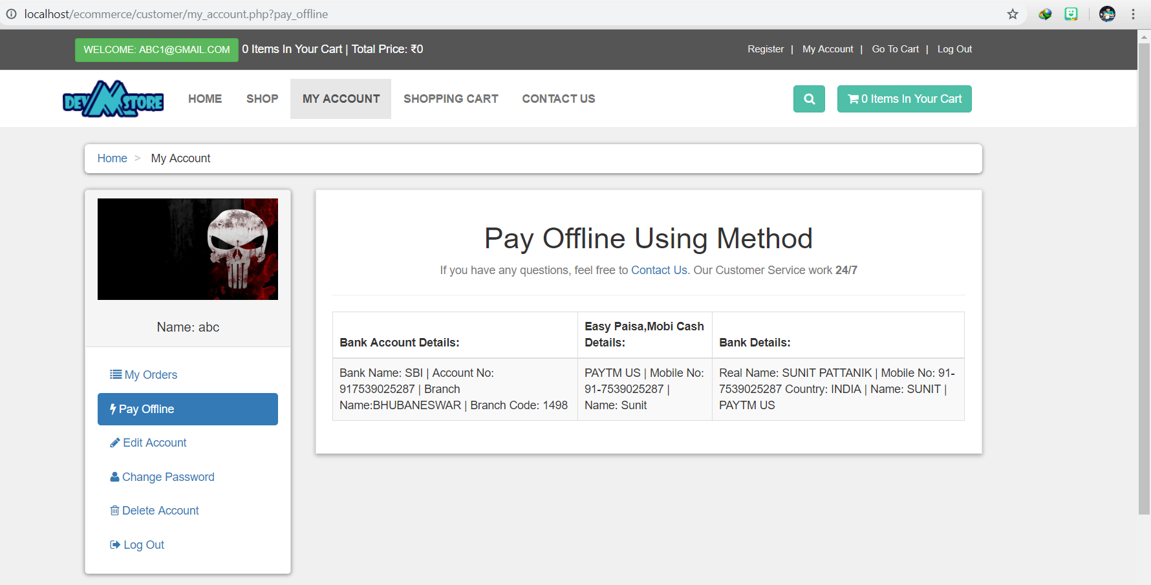

**Page | 48**

**CONTACT US**

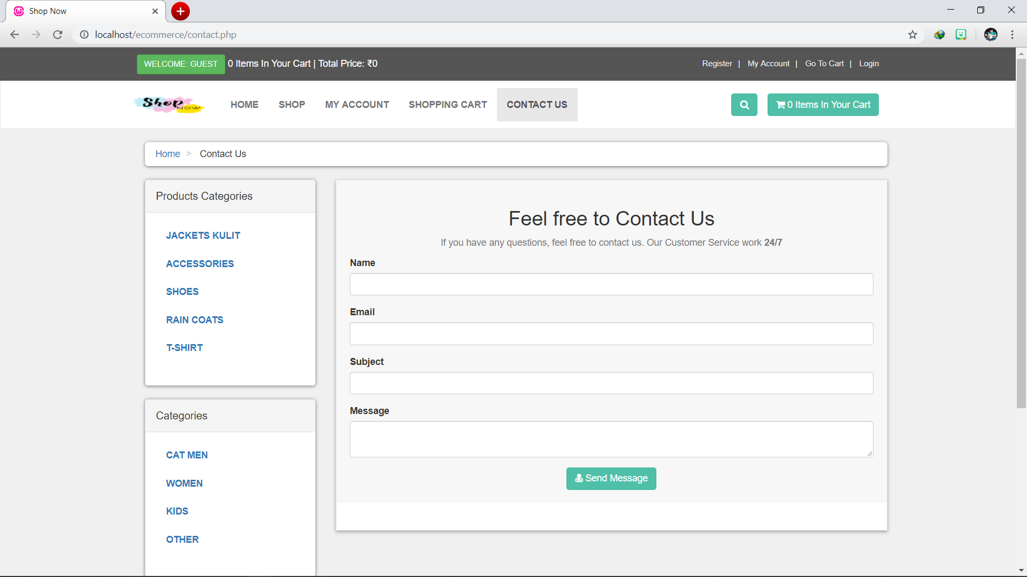

**DELETE ACCOUNT**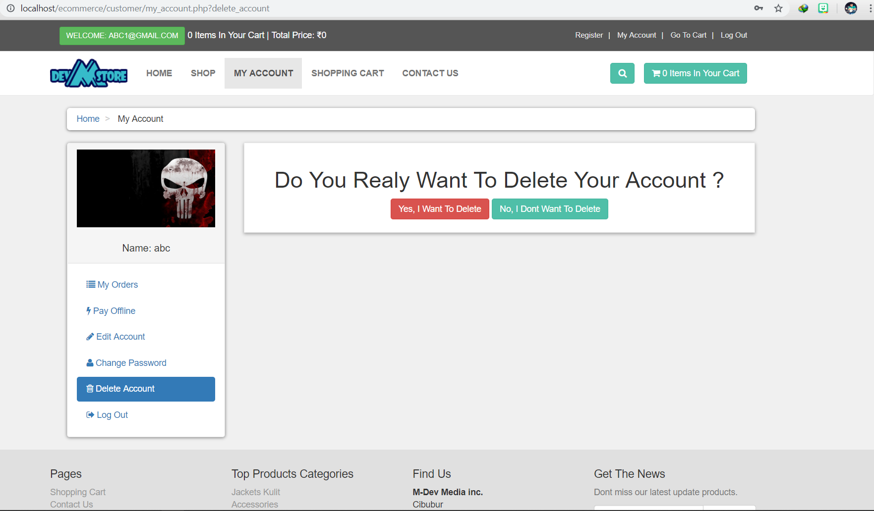

1. **CONCLUSION**

The package was designed in such a way that future modifications can be done easily. The following conclusions can be deduced from the development of the project.

Automation of the entire system improves the efficiency

* + It provides a friendly graphical user interface which proves to be better when compared to the existing system.
  + It gives appropriate access to the authorized users depending on their permissions.
  + It effectively overcomes the delay in communications.
  + Updating of information becomes so easier.
  + System security, data security and reliability are the striking features.
  + The System has adequate scope for modification in future if it is necessary.

**Page | 50**

1. **FUTURE ENHANCEMENTS**

This application avoids the manual work and the problems concern with it. It is an easy way to obtain the information regarding the various products information that are present in the Super markets.

Well I and my team members have worked hard in order to present an improved website better than the existing one’s regarding the information about the various activities. Still, we found out that the project can be done in a better way. Primarily, when we request information about a particular product it just shows the company, product id, product name and no. of quantities available. So, after getting the information we can get access to the product company website just by a click on the product name.

**Page | 51**

1. **BIBLIOGRAPHY**

The following book IS referred during the analysis and execution phase of the project

**WEB TECHNLOGIES BLACK BOOK**

(HTML, JAVASCRIPT, PHP, JAVA, JSP, ASP.NET, XML and AJAX)

**BLACK BOOK, DT EDITORIAL SERVICES**

**WEBSITES:**

* [www.google.com/](http://www.google.com/)
* [www.w3schools.com](http://www.w3schools.com)
* [www.tutorialspoint.php](http://www.tutorialspoint.php)
* <http://stackoverflow.com>

Page | **52**